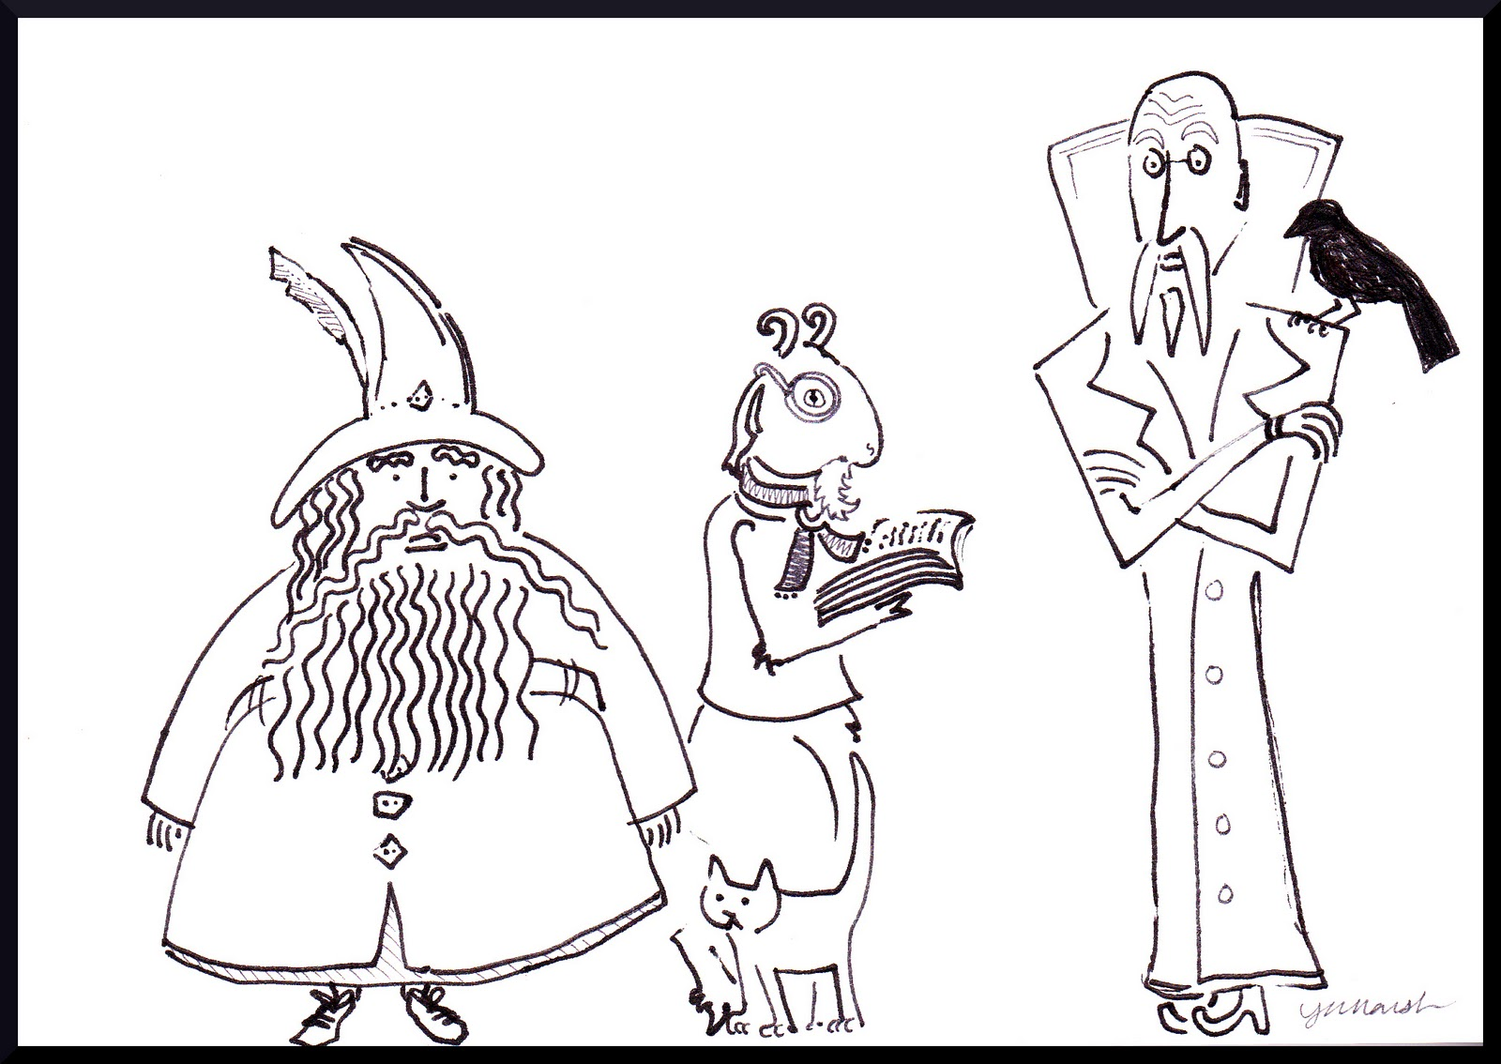
Three Wizards: Doscount School of Theurgy and Divination
Where Failure is ALWAYS An Option!

Congratulations Prospective Student!
You have succeeded in your quest to attend The Three Wizards School of Theurgy and Divination and we are now utterly bankrupt. We were perhaps totally bankrupt there for a solid week or so but with hard work, determination and a questionable oath to a lesser demon, we are proud to announce that we have upgraded that to merely utterly bankrupt.
Furthermore, we are pleased to let you know that all student fees collected as a part of your application are NON-REFUNDABLE and do not affect our golden parachutes nor our standing with our new lesser demon overlord.
However, all is not lost for you, our true-believing student either. Thanks to some high-risk financial horse-trading as well as some questionable late-night gambling, you will not be forgotten... or you could be, we don't know and it doesn't really affect us anymore. Are you writing this down again? Well, don't. Do a new draft and don't screw it up like last time. Anyway... We have managed to secure your indebtedness to us as part of a bundle of toxic assets left over from the 2008 financial crisis, which has been bought up by another school of some sort that we can only assume has the best of intentions. They will be in touch with you shortly to set up enrolment.
Meanwhile, please consider this a SPELL OF BANISHMENT and never contact us again*.

Sincerely,
The Three Wizards School's Former Upper Management

*NOTE: We are legally required under our bankruptcy agreement to point out that this is not in fact a real spell of banishment (our demon lord made us swear those off) but merely a legal restraining order. Really, NEVER CONTACT US AGAIN. May the gods shine down on you heartily or not.

